Zachary Frye
CSC 500
Module 5 Critical Thinking Assignment
Pseudocode:
- START
- Create dict of courses and details (use nested dictionary for optimization)
- Prompt user for course number
- If course number in courses:
  - Retrieve details from course dict
  - Print course number and details
- Else
  - Print course not found
- END
Source Code:
#Zachary Frye
#CSC 500
#3/1/2026
#Assignment 6

courses = {"CSC101": {"room": "3004", "instructor": "Haynes", "time": "8:00 AM"}, #create nested dictionaries for all data
"CSC102": {"room": "4501", "instructor": "Alvarado", "time": "9:00 AM"},
"CSC103": {"room": "6755", "instructor": "Rich", "time": "10:00 AM"},
"NET110": {"room": "1244", "instructor": "Burke", "time": "11:00 AM"},
"COM241": {"room": "1411", "instructor": "Lee", "time": "1:00 PM"}}

course_number = input("Enter a course number: ") #prompt user for course number
if course_number in courses: #check if course number is valid
details = courses[course_number] #retrieve course details from dictionary
print("Course: " + course_number) #print course number and details
print("Room: " + details["room"]) #print room number, instructor, and time
print("Instructor: " + details["instructor"])
print("Time: " + details["time"])
else:
print("Course not found.") #print error message if course number is invalid

Output:
PS C:\Users\pieor\OneDrive\Documents\school.lol4\CSU-MS-Stuff\CSC 500\Module 7> c:; cd 'c:\Users\pieor\OneDrive\Documents\school.lol4\CSU-MS-Stuff\CSC 500\Module 7'; & 'C:\Users\pieor\AppData\Local\Programs\Python\Python312\python.exe' 'c:\Users\pieor\.vscode\extensions\ms-python.debugpy-2025.18.0-win32-x64\bundled\libs\debugpy\launcher' '52965' '--' 'c:\Users\pieor\OneDrive\Documents\school.lol4\CSU-MS-Stuff\CSC 500\Module 7\ZachFrye_CSC500_Module7Assignment.py'
Enter a course number: ratio
Course not found.
PS C:\Users\pieor\OneDrive\Documents\school.lol4\CSU-MS-Stuff\CSC 500\Module 7> ^C
PS C:\Users\pieor\OneDrive\Documents\school.lol4\CSU-MS-Stuff\CSC 500\Module 7>
PS C:\Users\pieor\OneDrive\Documents\school.lol4\CSU-MS-Stuff\CSC 500\Module 7> c:; cd 'c:\Users\pieor\OneDrive\Documents\school.lol4\CSU-MS-Stuff\CSC 500\Module 7'; & 'C:\Users\pieor\AppData\Local\Programs\Python\Python312\python.exe' 'c:\Users\pieor\.vscode\extensions\ms-python.debugpy-2025.18.0-win32-x64\bundled\libs\debugpy\launcher' '59344' '--' 'c:\Users\pieor\OneDrive\Documents\school.lol4\CSU-MS-Stuff\CSC 500\Module 7\ZachFrye_CSC500_Module7Assignment.py'
Enter a course number: CSC101
Course: CSC101
Room: 3004
Instructor: Haynes
Time: 8:00 AM
PS C:\Users\pieor\OneDrive\Documents\school.lol4\CSU-MS-Stuff\CSC 500\Module 7>

Screenshot:
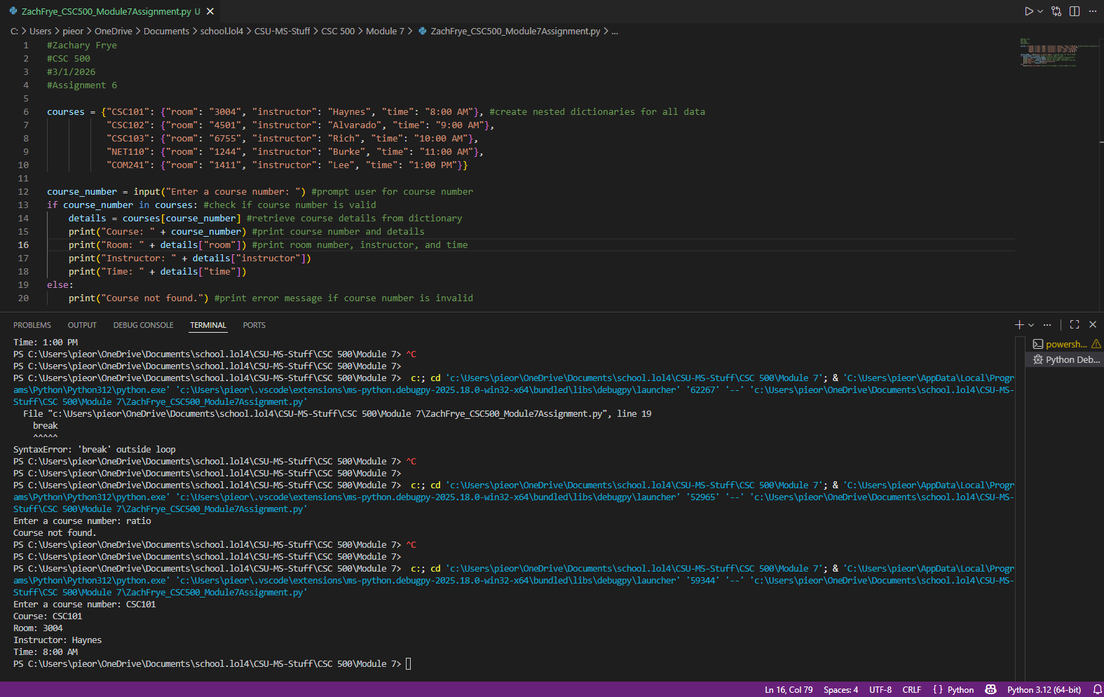
GitHub Repository

